BBI JU STAKEHOLDER FORUM 2019 - REGISTER NOW!

*12 September 2019*

[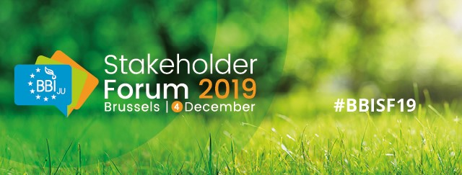](https://stakeholderforum.bbi.europa.eu/)

**We are pleased to inform you that registration for the next BBI JU Stakeholder Forum is open!  
   
The #BBISF19 will take place on 4 December 2019 in Brussels.**

[**Register now!**](https://stakeholderforum.bbi.europa.eu/bbi2019)

**ABOUT THE EVENT**  
The BBI JU Stakeholder Forum 2019 will bring together the bio-based industries community and facilitate open discussion on the impact, achievements and strategic direction of the Bio-based Industries Joint Undertaking (BBI JU) programme, as well as the latest developments in the bio-based industries sector.   
   
**THE PROGRAMME**  
BBI JU will present a comprehensive [programme](https://stakeholderforum.bbi.europa.eu/bbi2019/pages/programme)of high-level speakers, who will present their ideas through inspiring keynote speeches, pertinent panel discussions and parallel sessions.  
There will be also networking opportunities and a project exhibition where 100 granted projects will present their work. Bringing projects together in one venue with other BBI JU stakeholders, will facilitate the exchange of ideas and best practices.  
   
**WHO**  
We welcome all our stakeholders: industry, SMEs, academia, research organisations and policymakers, opinion leaders, EU community, BBI JU projects’ participants and bio-based industries community as a whole.  
   
**WHERE**  
The event will take place at the [Egg Congress and Meeting Center](https://www.theeggbrussels.com/) in Brussels.